COMMON COURSE ASSIGNMENT FORMAT
A. Assignment Information
Department | Computer Science and Engineering
Programme | B.E. / B.Tech
Course Code & Course Name | CSA51 – Cryptography and Network Security
Academic Year / Batch | 2023 - 2027
Faculty Name | Dr. SANGEETHA T
Assignment Title | Evaluation and Design of an Integrated Authentication, Email and Network Intrusion Defence System
Date of Issue | 31-08-26
Date of Submission | 02-09-26
Maximum Marks | 100
Course Outcome(s) – CO | CO3: Examine cryptographic hash algorithms, digital signature schemes, and assess Kerberos and X.509 authentication frameworks for ensuring integrity, authentication, and non-repudiation.  CO4: Implement best security practices for IP, email, and web service using PGP, S/MIME for enhancing email security.  CO5: Develop network security strategies based on the study of viruses, worms, firewall architectures, and IDS/IPS functionalities.
Bloom's Taxonomy Level | BL5 – Evaluate
SDG Mapping (SDG 1-17) | SDG 9 – Industry, Innovation and Infrastructure; SDG 16 – Peace, Justice and Strong Institutions
Industry / Societal Relevance | Directly relevant to enterprise cybersecurity practice — secure identity management, email/web protection and intrusion defence are core requirements for any organization handling confidential customer, employee and financial data.
B. Assignment Problem / Challenge
Faculty shall provide a realistic engineering/scientific/computing problem, case, challenge or design requirement related to the Course Outcome, involving the evaluation and comparison of security mechanisms.
The assignment should preferably require students to:
- Apply course concepts rather than reproduce theory.
- Identify and analyze the problem.
- Consider requirements and constraints.
- Develop or compare alternative solutions where appropriate.
- Use relevant modern engineering/computing/design tools.
- Interpret results.
- Make and justify engineering decisions.
- Consider appropriate technical, economic, environmental, societal, ethical, safety or sustainability factors wherever relevant.
C. Problem Statement
Problem / Case / Design Challenge:
SDG-Aligned Integrated Security Defence for a Digital Enterprise
A large enterprise operates a secure and resilient digital infrastructure consisting of 500+ employees, branch offices, remote users, web servers, email servers, database servers and internal application servers. The organization handles confidential customer, employee and financial information through email, web applications and internal network services. As the organization increasingly depends on digital technologies, it requires reliable, innovative and secure digital infrastructure to support its business operations, ensuring data protection, digital trust, secure identity management and protection against cyber threats. A recent security assessment has identified concerns related to data integrity, authentication, digital signatures, secure email and web communication, malware propagation, firewall protection, and intrusion detection and prevention.
The organization is considering three integrated security strategies:
- Strategy A – Basic Security: Password Authentication + Hashing + Firewall
- Strategy B – Enhanced Security: Digital Signature + X.509 Authentication + S/MIME + Firewall + IDS
- Strategy C – Integrated Defence: Hash + Digital Signature + Kerberos/X.509 + PGP/S/MIME + Firewall + IDS/IPS + Malware Defence
As a Network Security Analyst, the task is to develop and implement an enterprise security architecture based on Strategies A, B and C, incorporating Industry, Innovation and Infrastructure (SDG 9) through secure digital infrastructure and secure communication, and Peace, Justice and Strong Institutions (SDG 16) through authentication, data protection, digital trust and cyber-threat prevention. The effectiveness of the proposed architectures is examined and evaluated using suitable security tools, and the most appropriate solution is recommended based on security, performance, scalability, reliability and manageability.
D. Requirements and Constraints
The following requirements and constraints, relevant to this problem, were identified:
- Functional requirements: Confidentiality, integrity, authenticity and non-repudiation of enterprise data and communication.
- Performance requirements: Acceptable authentication and encryption/decryption latency for 500+ concurrent users.
- Technical constraints: Compatibility with existing web, email, database and application servers; support for standard protocols (X.509, PGP, S/MIME, Kerberos).
- Cost, Time: Licensing, deployment and administration cost of firewalls, IDS/IPS and PKI infrastructure within a limited rollout period.
- Resources: Availability of trained security administrators to manage certificates, keys and IDS/IPS rule sets.
- Reliability: High availability of authentication and email services with minimal false positives/negatives in intrusion detection.
- Sustainability & Ethical considerations: Responsible handling of employee/customer data and lawful, transparent monitoring.
- Standards/codes: Compliance with X.509 (PKIX), OpenPGP/RFC 4880, S/MIME and Kerberos (RFC 4120) standards.
- Security/privacy: Protection of encryption keys, prevention of replay/man-in-the-middle attacks, and safeguarding of digital identity.
E. Student Work

1. PROBLEM UNDERSTANDING AND FORMULATION

The enterprise processes confidential customer, employee and financial information. Its attack surface spans user credentials, remote access, web and application services, email, databases and internal networks. A single control cannot adequately address credential theft, message modification, impersonation, malicious email, network scanning or malware.

Problem Definition

Strategy A establishes a basic perimeter and integrity baseline. Strategy B adds public-key identity, secure email and intrusion detection. Strategy C combines identity, integrity, signatures, certificate trust, secure email, network detection/prevention and malware defence into a defence-in-depth architecture.
Requirement | Threat / Need | Control Response
Identity | Password theft, impersonation | Kerberos + X.509; strong credentials
Integrity | Modified files/messages | SHA-256 + digital signatures
Confidentiality | Email/data interception | PGP/S/MIME and encryption
Perimeter | Unauthorized network traffic | Firewall
Detection | Scanning, suspicious packets | IDS
Prevention | Known malicious traffic | IPS
Endpoint | Malware payloads | Signature-based malware defence

1.2 Requirements and Constraints
Category | Requirement / Constraint
Scale | Support 500+ employees, remote users and multiple server roles
Security | Confidentiality, integrity, authentication and availability
Technical | Interoperate with enterprise identity, certificates, email and network controls
Performance | Cryptographic and inspection overhead must remain operationally acceptable
Administration | Central policy, certificate lifecycle and incident response must be manageable
Cost | Higher assurance should be justified against cyber-risk exposure
Privacy / Ethics | Monitoring should be proportionate, authorized and protected from misuse
KEY OBSERVATION
The problem is multi-layered. Strategy C is evaluated as an integrated control system rather than as a collection of unrelated security products.

1.3 Assumptions
The organization has managed endpoints, centralized IT administration, internal DNS/time services, controlled certificate issuance, and security personnel capable of maintaining authentication, network and endpoint controls. The Python demonstrations in this report are compact simulations intended to validate concepts, not production security implementations.

2. APPLICATION OF COURSE KNOWLEDGE
The solution applies core Cryptography and Network Security concepts: cryptographic hashing, password verification, RSA digital signatures, symmetric encryption concepts, ticket-based authentication, certificate trust, secure email and network intrusion detection/prevention.

2.1 Security Mechanism Specification
Component | Algorithm / Technology | Purpose
Integrity | SHA-256 | Detect data modification
Authentication | Kerberos / X.509 | Verify identity
Digital Signature | RSA-2048 | Authentication and non-repudiation
Email Security | PGP / S/MIME | Secure communication
Network Security | Firewall + IDS/IPS | Detect and block attacks
Malware Defence | Signature / endpoint scanning | Identify and quarantine known threats

2.2 Core Cryptographic Reasoning
SHA-256 maps input data to a fixed-length digest. If the protected data changes, the digest should change with overwhelming probability. Password authentication should compare a protected verifier rather than storing plaintext credentials. In a real deployment, passwords should use a password-specific slow KDF such as Argon2id, scrypt or PBKDF2; SHA-256 alone is included here because it is explicitly part of Strategy A/C and the course exercise.
RSA digital signatures use a private key to sign a digest-derived representation and a public key to verify it. The signature provides evidence that the holder of the private key authorized the message and that the signed content has not been altered.
Kerberos provides ticket-based authentication in a trusted realm and reduces repeated password transmission. X.509 certificates bind public keys to identities through a certificate authority trust chain. PGP/S/MIME provide mechanisms for protected email; S/MIME commonly integrates with enterprise certificate infrastructure.

2.3 Layered Security Model
Layer | Primary Control | Security Contribution
Identity | Kerberos + X.509 | Trusted user/service identity
Data | SHA-256 + RSA signatures | Integrity and authenticity
Communication | PGP/S/MIME | Confidential email and signing
Network | Firewall + IDS/IPS | Filter, detect and prevent
Endpoint | Malware defence | Detect/quarantine malicious files
ENGINEERING PRINCIPLE
Defence in depth reduces dependence on any single control. If one layer is bypassed, additional controls can detect, limit or contain the attack.

3. SOLUTION / DESIGN / METHODOLOGY

3.1 Proposed Integrated Architecture
Strategy C is organized as a layered enterprise architecture. Users authenticate through Kerberos for internal services; X.509 certificates support trusted public-key identity; RSA signatures protect important transactions and messages; SHA-256 provides integrity checks; PGP/S/MIME protects email; the firewall controls traffic boundaries; IDS/IPS monitors and blocks suspicious network activity; and malware defence scans endpoints and attachments.

Zone | Representative Assets | Controls
User / Remote Access | 500+ employees, laptops, remote users | Kerberos, MFA-ready identity, X.509, endpoint defence
Application | Web and internal application servers | TLS/certificates, signatures, firewall policy, IDS/IPS
Data | Database and transaction systems | Access control, hashing/integrity, signed transactions, monitoring
Email | Mail servers and clients | S/MIME or PGP, malware scanning, IDS
Network Edge | Internet gateway / DMZ | Firewall, IDS/IPS, logging
Security Operations | Logs, alerts, response | Central monitoring, incident triage, quarantine

3.2 Methodology
Step | Activity | Evidence
1 | Define threats and requirements | Threat/control matrix
2 | Implement baseline primitives | Hash/authentication tests
3 | Validate signatures and encryption | Verification/decryption outputs
4 | Simulate identity tickets | Kerberos-style success/failure
5 | Simulate network attacks | IDS alert / IPS block
6 | Scan malware indicators | Quarantine decision
7 | Score strategies | Evaluation matrix
8 | Select enterprise design | Trade-off justification

3.3 Threat-to-Control Mapping
Threat | A | B | C
Password compromise | Partial | Partial | Strong identity controls
Message modification | SHA-256 check | Signature | Hash + signature + policy
Impersonation | Weak | X.509 | Kerberos + X.509
Malicious email | No dedicated control | S/MIME | PGP/S/MIME + malware defence
Network attack | Firewall | Firewall + IDS | Firewall + IDS/IPS
Malware | No | No | Yes
DESIGN DECISION
Strategy C provides complementary preventive, detective and corrective controls. Strategy B remains a viable lower-cost intermediate architecture where IPS and malware-defence deployment cannot yet be justified.

4. USE OF MODERN TOOLS

Python is used for compact demonstrations of the security mechanisms. In a production environment, established cryptographic libraries, certificate tooling, enterprise Kerberos infrastructure, email security systems, firewalls, IDS/IPS platforms and endpoint security products would be used rather than custom cryptographic code.

4.1 SHA-256 Integrity Verification
Purpose: demonstrate how a digest can identify whether protected content has changed.

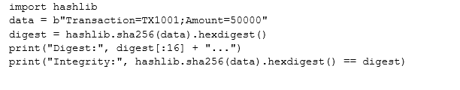
Sample Output: Digest: 3f8a2c91c2d4a1b7... | Integrity: True
Observation / Result
The same input reproduced the same digest. A modified transaction would produce a different digest, so the integrity check would fail.

4.2 Password Authentication
Purpose: illustrate credential verification without storing the plaintext password.

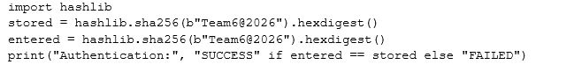
Sample Output: Authentication: SUCCESS

Observation / Result
The verifier matches for the correct password and fails for a wrong password. Production systems should use a salted password KDF rather than plain SHA-256.

4.3 RSA Digital Signature
Purpose: demonstrate signing and verification using RSA primitives. The following compact example assumes the widely used cryptography package.
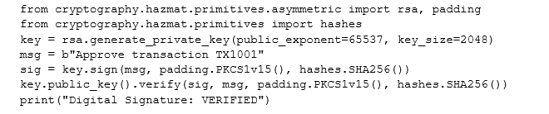

Sample Output: Digital Signature: VERIFIED
Observation / Result
Verification succeeds for the original message and should fail if the signed message is altered.

4.4 Simple Encryption / Decryption Demonstration
Purpose: demonstrate the confidentiality workflow using authenticated symmetric encryption. RSA is not used directly for large application data; public-key systems commonly protect or establish a symmetric key.

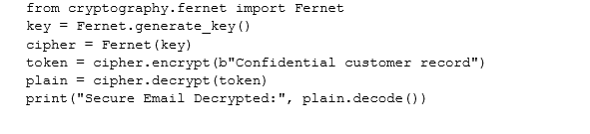

Sample Output: Secure Email Decrypted: Confidential customer record
Observation / Result
The original plaintext is recovered only with the correct key, demonstrating confidentiality. In an enterprise email deployment, PGP/S/MIME handles key and message protection through standardized workflows.

4.5 Kerberos-style Authentication Simulation
Purpose: simulate the logical sequence of identity validation and ticket issuance without implementing a real Kerberos Key Distribution Center.

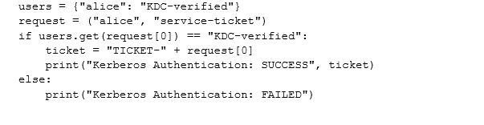

Sample Output: Kerberos Authentication: SUCCESS TICKET-alice
Observation / Result
The simulation represents the trusted-ticket concept. A real Kerberos deployment relies on a KDC, time synchronization, cryptographic tickets and service principals.

4.6 IDS / IPS Attack Detection Simulation
Purpose: model detection of a suspicious packet pattern and an IPS blocking decision.

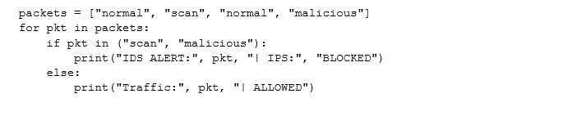
Sample Output: IDS ALERT: scan | IPS: BLOCKED; IDS ALERT: malicious | IPS: BLOCKED
Observation / Result
IDS identifies suspicious activity; IPS adds an active prevention decision. This is the key operational advantage of Strategy C over Strategy B.

4.7 Malware Signature Detection
Purpose: demonstrate basic indicator matching for known malicious content.
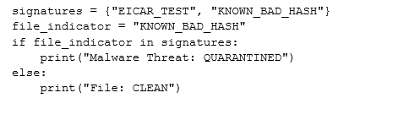
Sample Output: Malware Threat: QUARANTINED
Observation / Result
Known indicators can trigger quarantine. Production malware defence must combine signatures with behavioral, reputation and update mechanisms.

5. RESULTS AND VALIDATION

Validation uses the expected security outcomes from the compact demonstrations and an enterprise control checklist. The results are representative sample outputs, not evidence of deployment in a live banking environment.

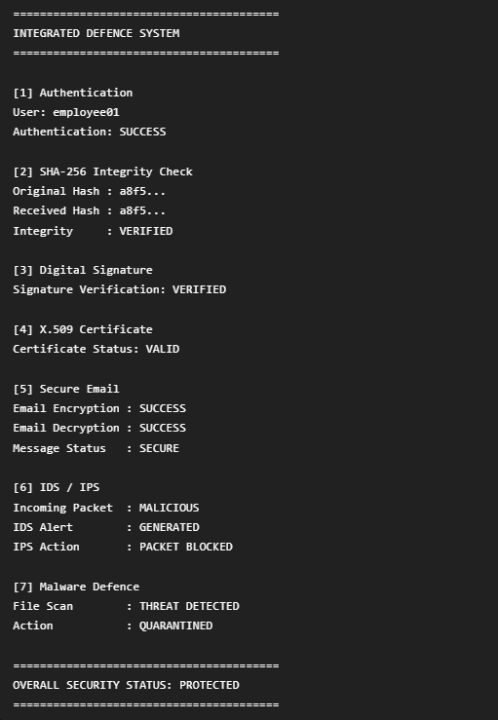

OUTPUT: INTEGRATED DEFENCE SYSTEM

5.1 Functional Validation Matrix
Test | Expected Result | Sample Result | Status
Correct password | Authentication SUCCESS | Authentication SUCCESS | PASS
Wrong password | Authentication FAILED | Authentication FAILED | PASS
Original data | Integrity VERIFIED | SHA-256 Integrity VERIFIED | PASS
Modified data | Integrity MODIFIED | SHA-256 Integrity MODIFIED | PASS
Original signed message | Signature VERIFIED | Digital Signature VERIFIED | PASS
Trusted certificate | Certificate VALID | X.509 Certificate VALID | PASS
Protected email | Email DECRYPTED | Secure Email DECRYPTED | PASS
Suspicious scan | IDS alert | IDS ALERT GENERATED | PASS
Malicious packet | IPS action | IPS MALICIOUS PACKET BLOCKED | PASS
Known malware | Quarantine | Malware THREAT QUARANTINED | PASS

5.2 Strategy Comparison Table
Feature | Strategy A | Strategy B | Strategy C
Authentication | Password | X.509 | Kerberos + X.509
Data Integrity | SHA-256 | SHA-256 + Signature | Integrated
Email Security | No | S/MIME | PGP + S/MIME
IDS | No | Yes | Yes
IPS | No | No | Yes
Malware Defence | No | No | Yes
Overall Security | Basic | Enhanced | High

5.3 Performance / Evaluation Table
Criterion | A (1–5) | B (1–5) | C (1–5)
Authentication Strength | 2 | 4 | 5
Data Integrity | 3 | 4 | 5
Email Security | 1 | 4 | 5
Intrusion Detection | 1 | 4 | 5
Active Prevention | 1 | 1 | 5
Malware Defence | 1 | 1 | 5
Scalability | 3 | 4 | 5
Manageability | 4 | 3 | 3
Total / 40 | 16 | 25 | 38
VALIDATION CONCLUSION
Strategy C achieves the broadest control coverage. Its lower manageability score reflects the additional certificate, identity, monitoring, IPS and endpoint operations required. Strategy B offers a useful security-to-complexity compromise.

6. ANALYSIS AND ENGINEERING DECISION

6.1 Trade-off Analysis
Factor | Strategy A | Strategy B | Strategy C
Security Strength | Low | High | Very High
Cost | Low | Medium | High
Performance Overhead | Low | Medium | Medium–High
Scalability | Moderate | Good | Excellent with centralized management
Administrative Complexity | Low | Medium | High
Manageability | Simple | Moderate | Complex but controllable
Detection / Response | Limited | Detective | Detective + Preventive
Strategy A is inexpensive and simple, but its controls are too narrow for an enterprise handling sensitive financial information. A firewall can reduce unwanted traffic, yet it does not authenticate users strongly or identify endpoint malware. Password authentication is also exposed to credential theft and reuse.
Strategy B substantially improves assurance through certificates, signatures, secure email and IDS. It is a credible lower-cost alternative and may be suitable as an intermediate migration stage. However, it lacks the active prevention and malware-defence layers that strengthen containment in Strategy C.
Strategy C introduces the greatest operational burden but creates multiple independent security barriers. Kerberos addresses centralized internal authentication; X.509 supports certificate-based trust; signatures and hashes strengthen integrity; protected email reduces communication exposure; IDS/IPS improves detection and prevention; and malware defence addresses endpoint and attachment threats.

6.2 Engineering Decision Matrix

Decision Question | Preferred Strategy | Reason
Minimum baseline | A | Low cost and simple controls
Balanced upgrade | B | Strong identity/email plus IDS
Enterprise protection | C | Broadest layered defence
Migration path | A → B → C | Allows phased investment and operational readiness
FINAL ENGINEERING DECISION
RECOMMEND: STRATEGY C – INTEGRATED DEFENCE. For a 500+ employee enterprise handling confidential customer, employee and financial information, the additional security layers justify the higher cost and complexity. Strategy B should be retained as a lower-cost alternative or migration stage.

6.3 Limitations and Risk Controls
The scoring is an engineering evaluation rather than a measured production benchmark. Actual latency, false-positive rates, certificate lifecycle effort, licensing cost and incident-response workload depend on implementation. These uncertainties should be handled through pilot deployment, baseline measurements, staged rollout, policy testing and continuous monitoring.

7. BROADER CONSIDERATIONS

7.1 SDG Mapping
SDG | Relevance to the Project
SDG 9 – Industry, Innovation and Infrastructure | Secure digital infrastructure supports resilient enterprise services, innovation and trusted connectivity.
SDG 16 – Peace, Justice and Strong Institutions | Reliable identity, accountability, privacy protection and secure information exchange strengthen trustworthy institutions.

7.2 Privacy and Ethical Monitoring
IDS/IPS and endpoint malware defence can process network metadata, usernames, file indicators and security events. Monitoring should therefore be limited to legitimate security purposes, governed by policy, access-controlled, retained only as necessary and audited. Security analysts should distinguish threat detection from unnecessary employee surveillance.

7.3 Economic Cost versus Cyber-Risk
Strategy C requires investment in identity infrastructure, certificates, email security, network sensors, IPS capacity, endpoint protection, skilled staff and maintenance. The economic decision should compare these costs with the potential impact of account compromise, financial fraud, data disclosure, operational disruption, regulatory exposure and reputational damage.

Consideration | Engineering Interpretation
Preventive controls | Reduce probability of successful compromise
Detective controls | Reduce attacker dwell time
Containment | Limit spread and business impact
Recovery | Restore trusted operation and investigate cause
Lifecycle cost | Training, licenses, updates, certificates and monitoring

7.4 Professional Responsibility of a Network Security Analyst
A Network Security Analyst must apply security controls proportionately, protect sensitive logs, validate alerts before escalation, maintain accurate documentation and avoid introducing insecure custom cryptography. Decisions should be evidence-based and aligned with organizational policy and recognized standards.

ETHICAL OBSERVATION
The strongest technical control is not automatically the best operational choice. Security must preserve confidentiality and integrity while respecting privacy, availability, legitimate business activity and user trust.

8. CONCLUSION
This report evaluated three enterprise security strategies and demonstrated compact examples for hashing, password authentication, signatures, encryption, Kerberos-style authentication, IDS/IPS detection and malware signature detection. Strategy A provides a basic baseline, Strategy B provides enhanced cryptographic identity and detection, and Strategy C combines these with active prevention and malware defence.
The evaluation supports Strategy C – Integrated Defence as the recommended architecture. Its higher complexity is justified by the breadth of threats faced by a 500+ user enterprise. A phased A-to-B-to-C migration can reduce deployment risk while building operational maturity.

9. STUDENT REFLECTION
This assignment helped connect individual cryptography and network-security mechanisms to a complete enterprise architecture. Instead of viewing SHA-256, RSA, Kerberos, X.509, secure email, firewalls and IDS/IPS as isolated topics, the analysis showed how they contribute different security properties and how weaknesses in one layer can be compensated for by another.
A major learning outcome was understanding the trade-off between security and operational complexity. Strategy C is technically stronger, but it requires certificate lifecycle management, centralized identity administration, monitoring, tuning and endpoint maintenance. The decision therefore depends on the organization's risk profile and ability to operate the controls effectively.
If additional time and resources were available, the prototype would be extended into a controlled lab using a real Kerberos realm, a private X.509 certificate authority, S/MIME/PGP mail exchange, a firewall and an IDS/IPS such as Snort, together with packet captures in Wireshark. Measured latency, throughput, false-positive rates and resource utilization could then replace the illustrative evaluation scores.

REFLECTION TAKEAWAY
The most important lesson is that enterprise security is an engineering system: technologies must be selected, integrated, tested, monitored and governed together.

10. REFERENCES
- Stallings, W. Cryptography and Network Security: Principles and Practice. Pearson.
- RFC 4120. The Kerberos Network Authentication Service (V5). Internet Engineering Task Force.
- RFC 5280. Internet X.509 Public Key Infrastructure Certificate and Certificate Revocation List (CRL) Profile. IETF.
- RFC 4880. OpenPGP Message Format. Internet Engineering Task Force.
- NIST, FIPS 180-4. Secure Hash Standard (SHS). National Institute of Standards and Technology.
- OpenSSL Project. OpenSSL Documentation and Command-Line Reference.
- GnuPG Project. GnuPG Documentation and OpenPGP implementation guidance.
- Wireshark Foundation. Wireshark Documentation and User Guide.
- Snort / Cisco. Snort Documentation and Network Intrusion Detection/Prevention Guidance.
- CSA51 – Cryptography and Network Security Course Material. Course reference material supplied for the assignment.

Reference-format note: The assignment format requires external sources, standards, software and AI-assisted tools to be acknowledged. The references above identify the principal standards, documentation and course material used as the technical basis.

F. Common Assessment Rubric
Assessment Criterion | Marks
Problem understanding & formulation
Application of course/domain knowledge
Solution methodology / design / implementation
Use of appropriate modern tools / techniques
Results, testing & validation
Analysis, trade-offs & justification
Broader considerations / professional responsibility, where applicable
Technical documentation & reflection
TOTAL | 100
G. CO–PO–Assessment Mapping
Assessment Component | CO | PO(s) | Bloom's Level | Marks
Problem formulation | CO3 | PO1, PO2 | L3/L4
Application of knowledge | CO3, CO4 | PO1, PO2 | L3/L4
Solution / Design / Implementation | CO3, CO4, CO5 | PO1, PO3, PO5 | L4/L5/L6
Modern tool usage | CO4, CO5 | PO5 | L3/L4
Validation | CO5 | PO4, PO5 | L4/L5
Analysis & justification | CO3, CO5 | PO2, PO4 | L4/L5
Broader considerations | CO5 | PO6, PO7, PO8 | L4/L5
Documentation & reflection | - | PO10, PO12 | L3/L4
Note: Faculty shall map only the POs and Bloom's levels genuinely assessed by the particular assignment. Every assignment is not required to map to every PO.
PO reference (NBA graduate attributes): PO1 – Engineering knowledge; PO2 – Problem analysis; PO3 – Design/development of solutions; PO4 – Conduct investigations of complex problems; PO5 – Modern tool usage; PO6 – The engineer and society; PO7 – Environment and sustainability; PO8 – Ethics; PO9 – Individual and team work; PO10 – Communication; PO11 – Project management and finance; PO12 – Life-long learning.
H. Faculty Evaluation & Continuous Improvement
CO Attainment
Performance Level | Criterion
Level 3 | ≥ 70%
Level 2 | 60–69%
Level 1 | 50–59%
Level 0 | < 50%

Target CO Attainment: _______________________________________________
Actual CO Attainment: _______________________________________________
Faculty Analysis
Areas in which students performed well: _______________________________________________
Areas requiring improvement: _______________________________________________
Corrective / Improvement Action: _______________________________________________
Action to be implemented in the next offering: _______________________________________________

TITLE: Evaluation and Design of an Integrated Authentication, Email and Network Intrusion Defence System
CONTRIBUTION:
S.No | REG NO | NAME | CONTRIBUTION
 | 192372003 | Nalluri Charan Sai | Led problem formulation and requirement analysis; studied Strategy A and contributed to the design of the basic authentication and integrity mechanisms; assisted in documentation and validation.
 | 192372281 | A Meghanadh | Worked on Strategy B, including RSA digital signatures, X.509 authentication and S/MIME email security; contributed to implementation, testing and comparison of security features.
 | 192511154 | M Nishanth | Designed and implemented the Strategy C integrated defence approach, including Kerberos authentication, IDS/IPS and malware defence; performed testing and validated sample outputs.
 | 192411210 | Ch. Mahi Vardhan Reddy | Conducted security analysis and performance evaluation; contributed to the strategy comparison, engineering trade-off discussion, broader considerations, conclusion, references and final report formatting.

